NFHS Manual Review: 7. SCRIMMAGE KICK PLAYS

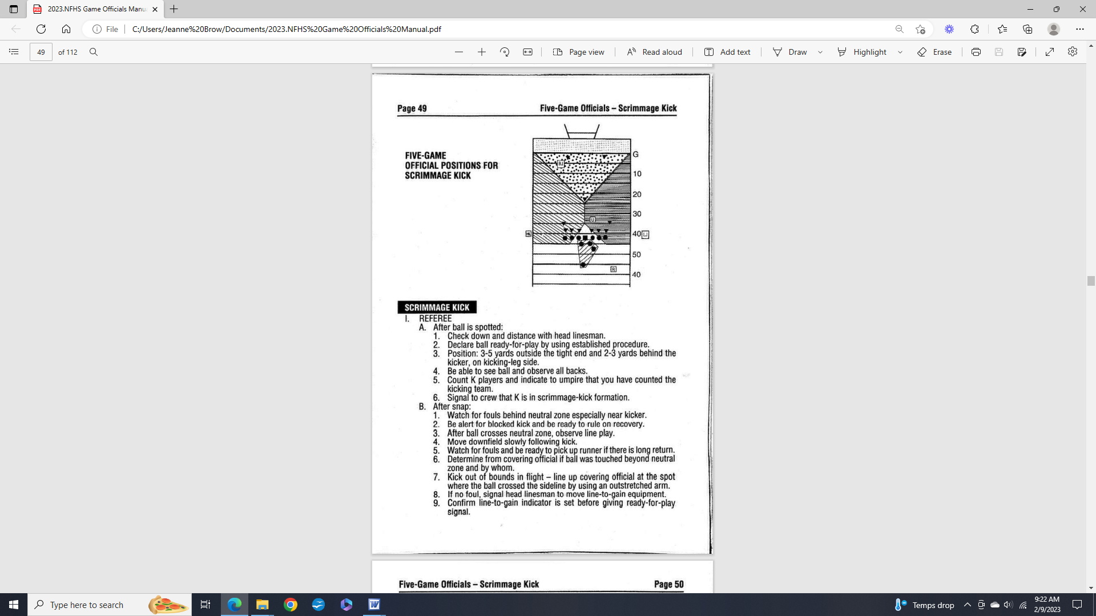
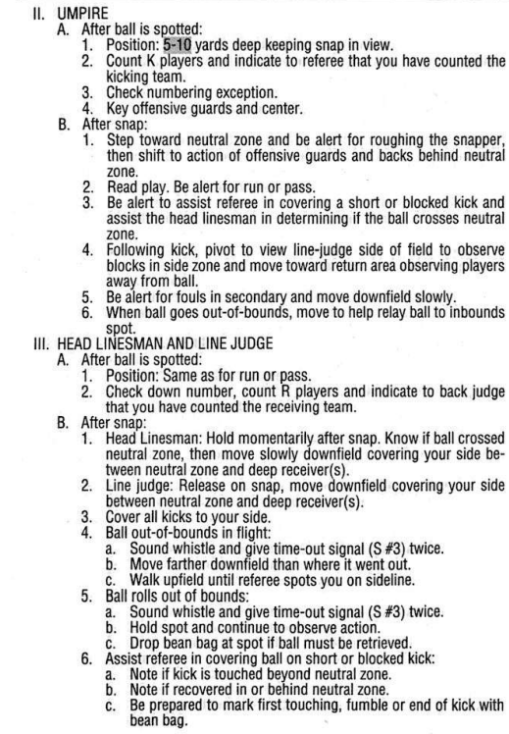
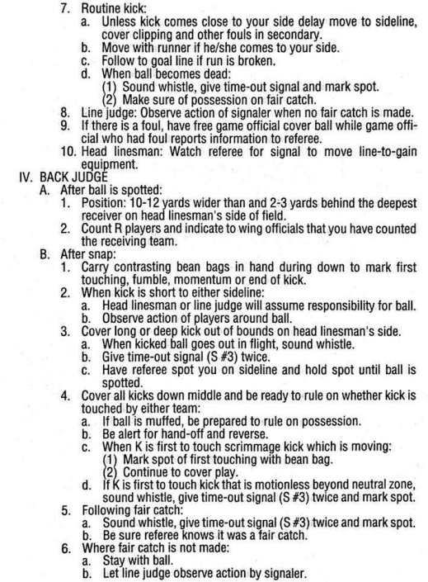
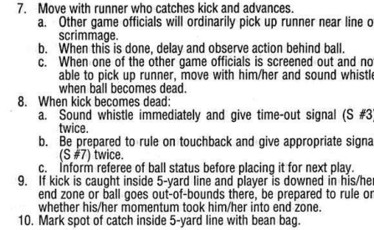

-----------------------------------------------------------------------------------------------------------

Massachusetts 5-Person NFHS Manual Review Committee

Comments - Section 7: Scrimmage Kick Plays

[ X ] - Committee Agrees with NFHS Manual with the following recommendations:

7. Scrimmage Kick Plays

a. The R will call the U over the ball until an accurate count is confirmed by the LJ. With the potential of 44 players coming and going, make sure there is an accurate count.

b. On the scrimmage kicks, the LJ should hold the line and the HL should break on a clean snap. The HL has action in front of the run. Once the ball crosses the LOS, the LJ breaks and picks up action in front of the runner.

c. When the ball becomes dead on a scrimmage kick, the covering official should hold the spot with the opponents ball until the offense brings in a new ball and the ball gets spotted by the U. Once the ball is spotted by the U, the other ball can be removed from the field of play.

