NFHS Manual Review: 6. PASSING PLAYS

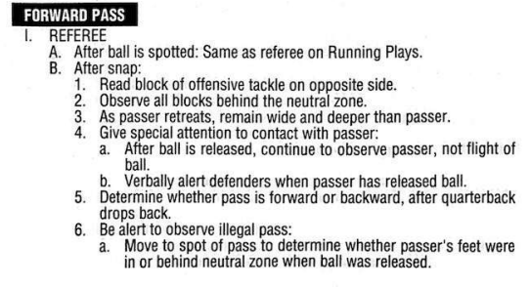

(Continued next page)

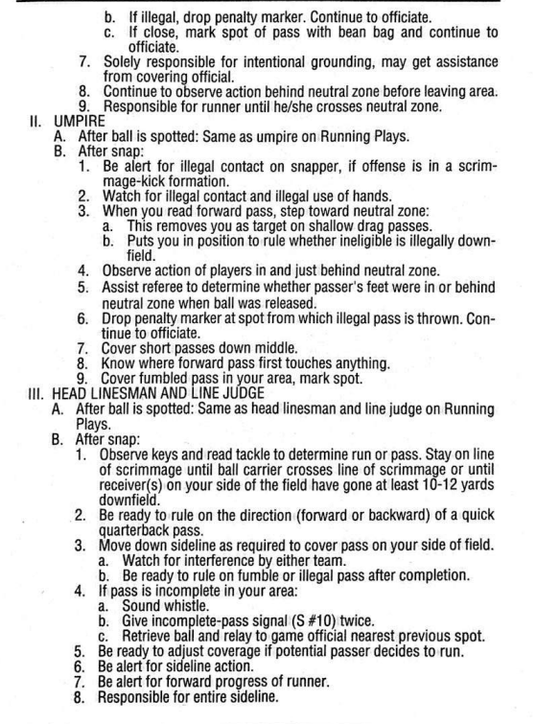

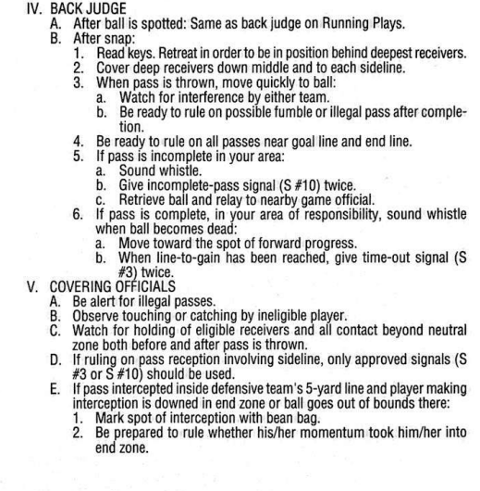
-----------------------------------------------------------------------------------------------------------

Massachusetts 5-Person NFHS Manual Review Committee

Comments - Section 6: Passing Plays

[ X ] - Committee Agrees with NFHS Manual with the following recommendations:

6. Passing Plays

a. When the U reads pass play, the U will moved to 2 yards depth to have a good point of reference of the extended neutral zone and for possible ineligibles downfield.

b. The HL, BJ, and LJ will use “Man-Zone-Ball” Technique for eligible receivers coverage.

c. Forward/Backward passes - When in doubt the pass is forward.

d. Quick Passes – the HL and LJ have primary responsibility. (The official that ball is going away from has the best look.)

e. Drop back passes/shotgun – the R has primary responsibility for backward pass. The HL and LJ have secondary responsibility for backward pass.

f. The far side wing official will punch backward passes. The ball remains alive and maybe advanced by anyone on any down. Backward passes OOB will be spotted at OOB spot for all downs as well.

g. If the BJ has a foul for OPI/DPI; then the HL, LJ or U will need to help pick up the flag. There is no foul for OPI/DPI if pass has not crossed NZ.

h. It is important to communicate if the ball on a pass has crossed the neutral zone; might have OPI or DPI.

i. Coverage of receivers/Keys – HL, LJ, BJ
- Discussion led by BJ; HL and LJ should be involved.
- The BJ has widest eligible receiver based on strength (usually the TE). If strength is even, strength will be declared on LJ’s side of the field.
- Discuss motion and how it affects keys. Watch motion for possible crack backs blocks.
g. Complete/Incomplete – HL, LJ, BJ, U, R
- Any official can call incomplete pass, if they are 100% certain.
- If ruled as a catch, covering official (HL, LJ, BJ, U) should sell the spot.
- If there is doubt, the pass should be ruled incomplete.
h. The R is primary on any hit on QB (blind side or front side).
- If the ball comes out, the R will rule incomplete or fumble.
- The R should signal and whistle if the pass is incomplete.
- If ruled a fumble, the R should throw a bean bag.
- The HL and LJ should key off R, delay your whistle to get the proper read from the R.
i. OPI/DPI – HL, LJ, BJ primary.
- OPI calling official needs to report foul to R; non-calling official will cover flag
- DPI non-calling official will cover flag; calling official will report to R
- Whether or not the foul is more or less than 15 yd penalty does not matter in NHFS Rules. The penalty for DPI is 15 yd penalty
- Half the distance apply when previous spot is inside the B30.
- The U will communicate to HL and LJ before enforcing all penalties.

