NFHS Manual Review - 4. Kickoff

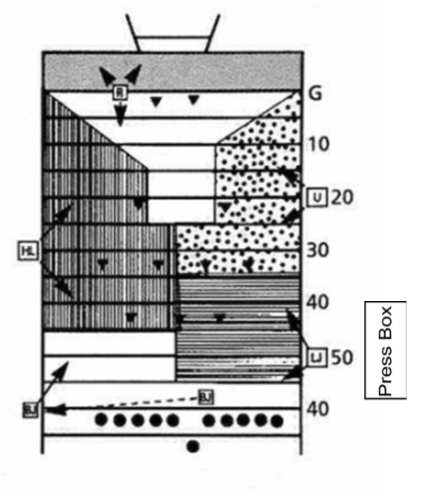
R - has the goal line
BJ - hands the ball to the kick then jogs to Kicking team's restraining line opposite the press box
LJ - has the Receiving team's restraining line (usually the 50)
HL - has the Receiving team's 30 yard line on the BJ sideline
U - has the Receiving team's 20 yard line on the LJ sideling

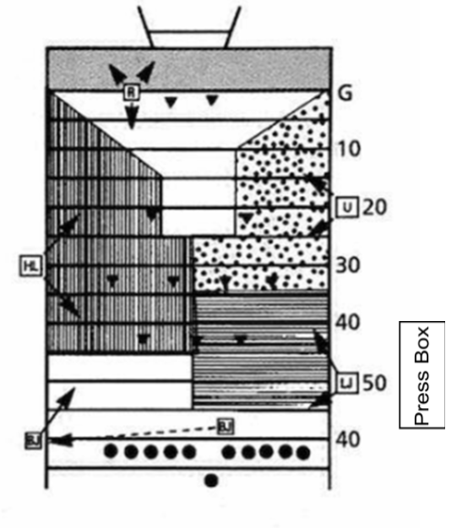
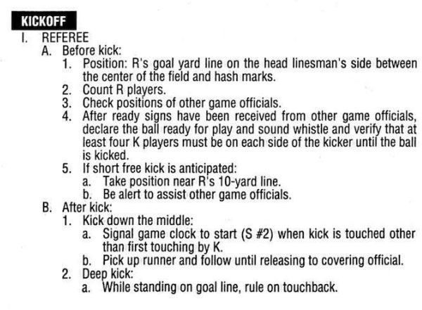

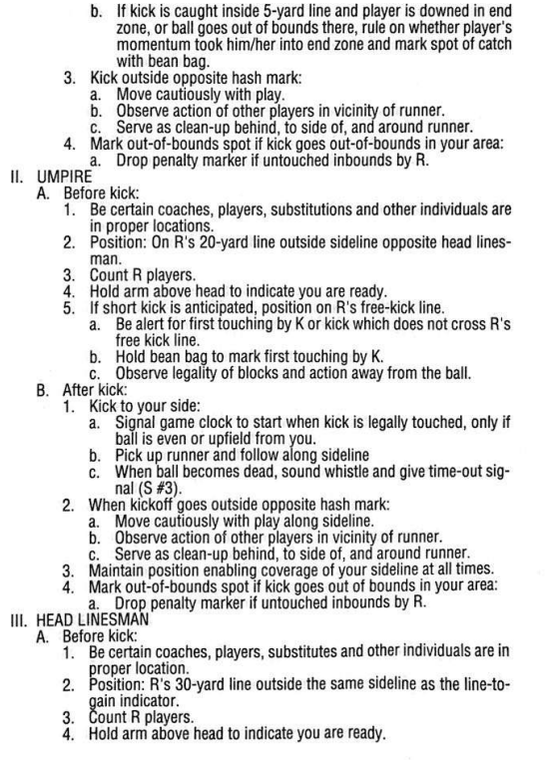

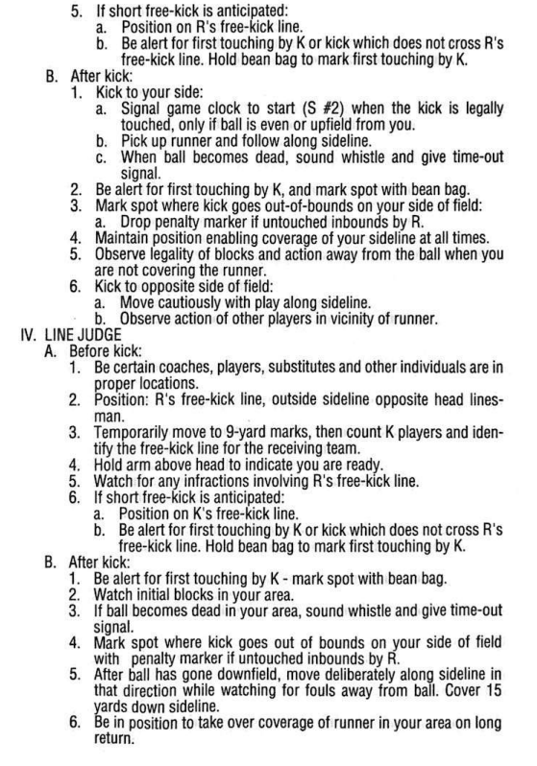
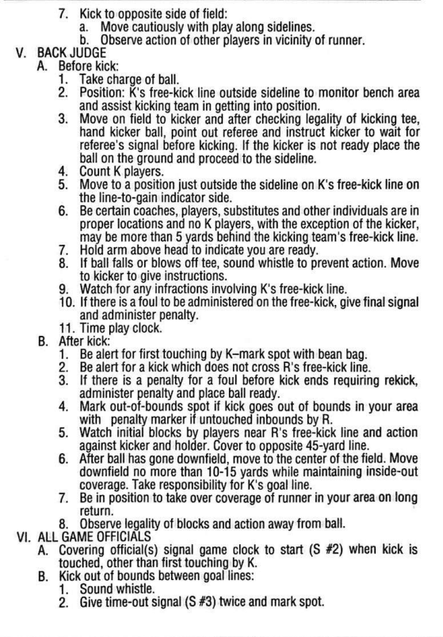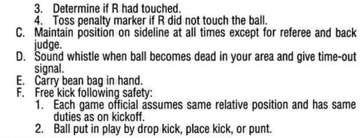

Massachusetts 5-Person NFHS Manual Review Committee

Comments - Section 4: Kickoffs

[ X ] - Committee Agrees with NFHS Manual with the following recommendations:

4. Kickoffs

a. Free Kick Off’s/Free Kicks:

Mass NFHS Manual Review Committee recommends that for teams who consistently perform short kicks and for teams that consistent perform long kicks (touchbacks) the R can change officials' positions during free kicks as follows:

(Continue reading on the next page)
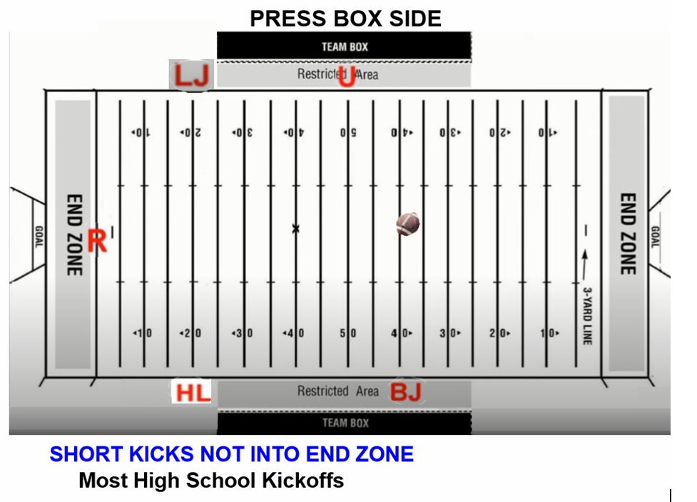

SHORT KICK (Most High School Kickoffs)
40 (kicking restraining line) yard line - BJ opposite the press box
50 (receiving restraining line) yard line - U press box side
20 yard line - HL opposite press box
20 yard line - LJ press box side
Goal line - R

(Continue reading on the next page.)

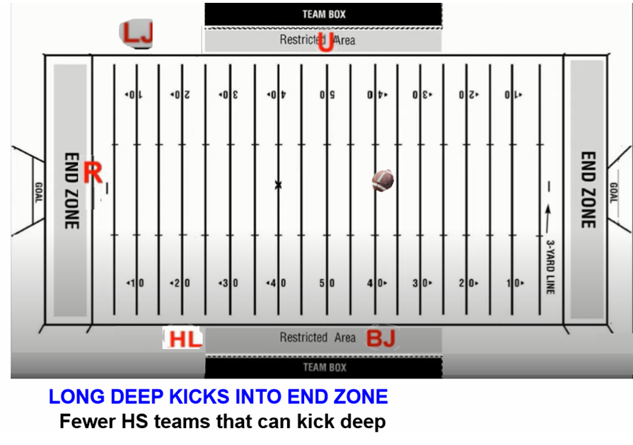

LONG KICK INTO END ZONE (Some High School Kickoffs)
40 (kicking restraining line) yard line - BJ opposite the press box
50 (receiving restraining line) yard line - U press box side
20 yard line - HL opposite the press box
10 yard line - LJ sets up initial position deeper on the press box side
Goal line pylon - R opposite press box

(Continue reading on the next page.)

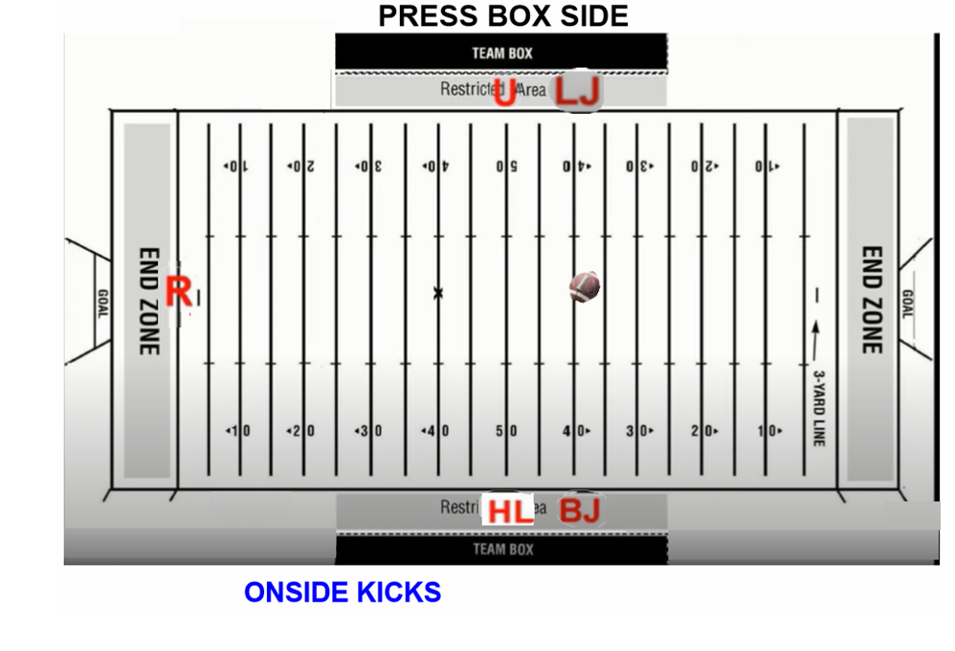
ONSIDE KICK
40 (kicking restraining line) yard line - BJ opposite the press box
50 (receiving restraining line) yard line - U press box side
50 yard line - HL opposite press box
40 yard line - LJ press box side
Goal line - R

b. The BJ checks to see that all kicking team players, except the kicker, are inside of 5 yards.

c. On all free kicks, the R checks to see that kicking team has at least four players on both sides of the kicker when that ball is kicked. The R will blow whistle and shut the kick down if there are only three or less on either side of the kicker when the ball is kicked.

d. Watch the kicker before the game and get a feel for how deep the player kicks the ball. If there is a weak kicker, the R will instruct the officials to move up. This is a game time decision. If you have a kicker who can boot the ball, you don't want to run back and have to run forward. It much easier to come up than it is to go down then back up.

e. Officials covering kicking team's restraining line and receiving teams' restraining line will have bean bags in hand to mark first touching within the restraining lines.

