NFHS Manual Review:
15. BETWEEN PERIODS PROCEDURE

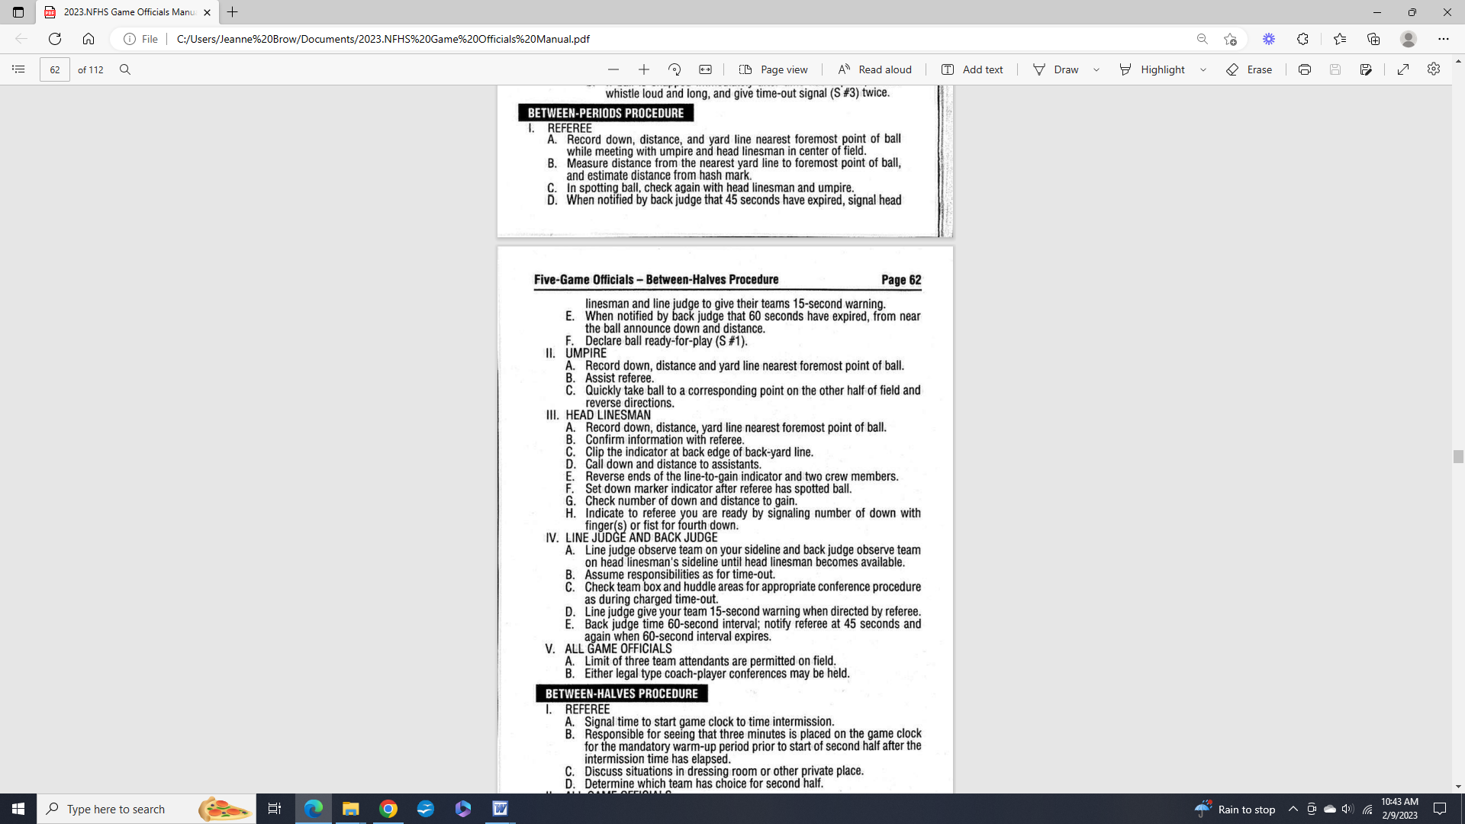

-----------------------------------------------------------------------------------------------------------

Massachusetts 5-Person NFHS Manual Review Committee

Comments - Section 15: Between Periods Procedure

[ X ] - Committee Agrees with NFHS Manual

