NFHS Manual Review:
10. ADMINISTERING PENALTIES

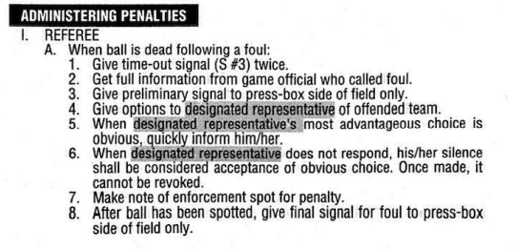

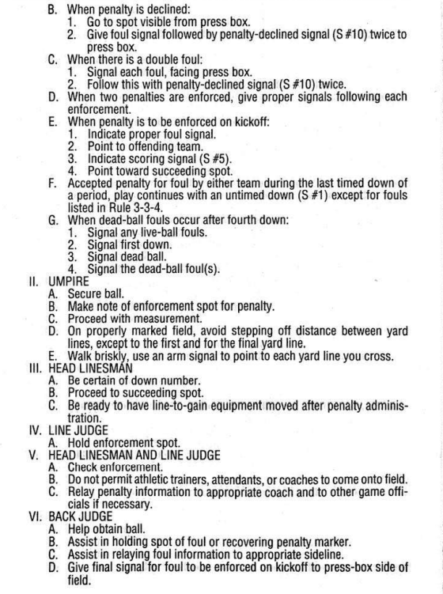

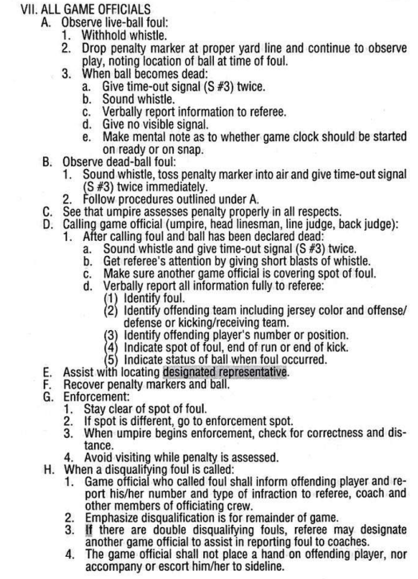
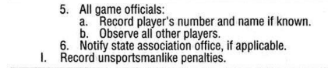

-----------------------------------------------------------------------------------------------------------

Massachusetts 5-Person NFHS Manual Review Committee

Comments - Section 10: Administering Penalties

[ X ] - Committee Agrees with NFHS Manual with the following recommendations:

10. Administering Penalties

a. The R confers with the Head Coach on accepting or declining penalties.
b. After the penalty is enforced, the BJ confirms with the R about the status of the clock. Determine if the clock starts on the Wind or on the Snap.
c. Know who is responsible for covering the flag and who is responsible for covering the end of the run. This will allow the calling official to report the penalty to the R. The U will march the penalty off with the HL or LJ.

