NFHS Manual Review: 1. PREGAME

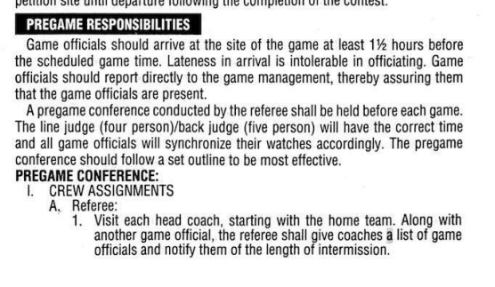
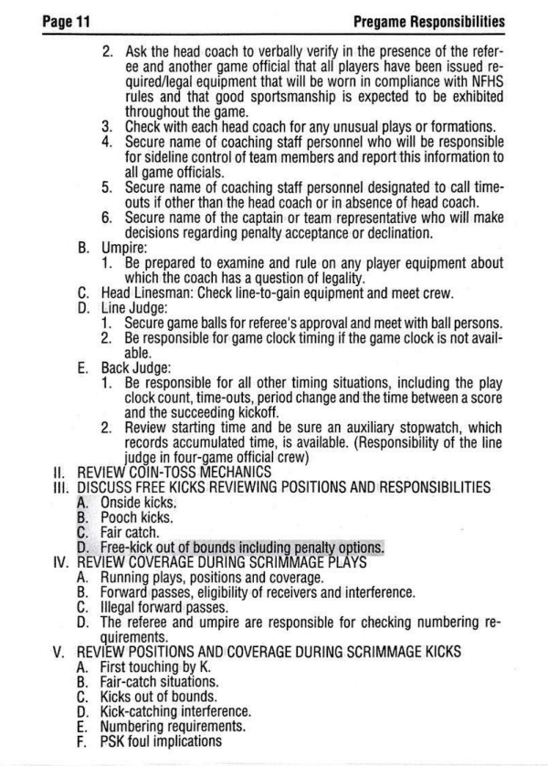

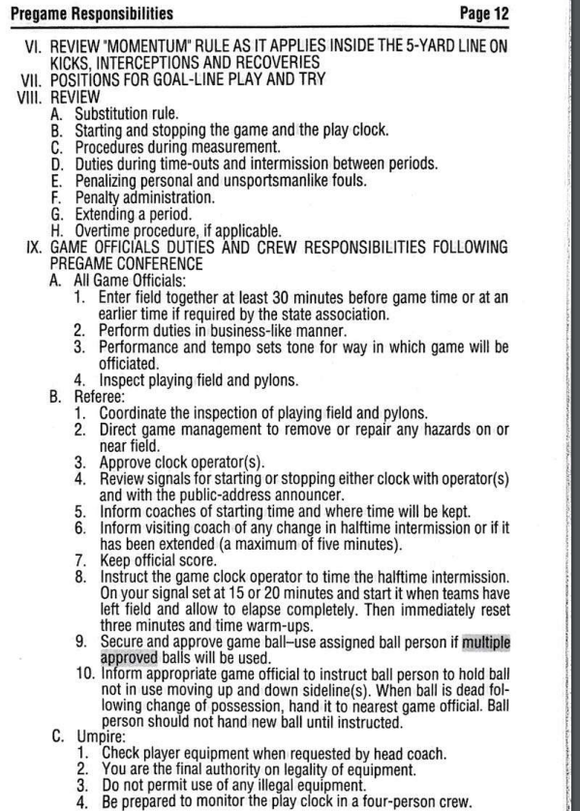

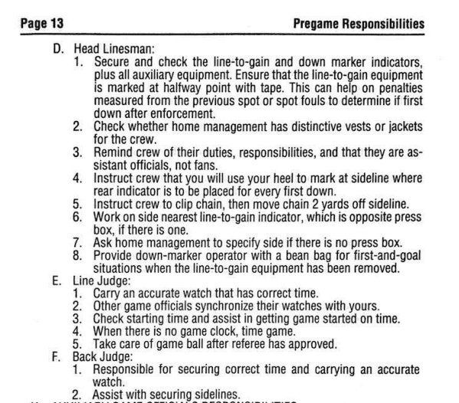

-----------------------------------------------------------------------------------------------------------

Massachusetts 5-Person NFHS Manual Review Committee

Comments - Section 1: Pre-Game Responsibilities

[ x ] - Committee Agrees with NFHS Manual with the following recommendations:
- Pre-Game Responsibilities
a. Under pre-game conference, the LJ will confirm and identify each team has a licensed physician, licensed athletic trainer or certified EMT prepared to handle injuries on the field.
b. All officials will spot check player equipment during pre-game, check on field conditions, and focus on player pads.

c. The BJ reviews with the Head Coach the procedure for the 40-25 second count; hand up at 10 seconds and down at 5 seconds. As time runs out, throw the flag.

d. The BJ inspects and approves game balls for both teams during the pre-game. Any official may approve the game balls as they come into play during the game.

e. The R will consult with the Head Coach or designee regarding penalty decisions.

