Massachusetts NFHS Manual Addendum

- Pre-Game Responsibilities
a. Under pre-game conference, the LJ will confirm and identify each team has a licensed physician, licensed athletic trainer or certified EMT prepared to handle injuries on the field.
b. All officials will spot check player equipment during pre-game, check on field conditions, and focus on player pads.

c. The BJ reviews with the Head Coach the procedure for the 40-25 second count; hand up at 10 seconds and down at 5 seconds. As time runs out, throw the flag.

d. The BJ inspects and approves game balls for both teams during the pre-game. Any official may approve the game balls as they come into play during the game.

e. The R will consult with the Head Coach or designee regarding penalty decisions.

- Coin Toss
a. The R will be efficient in signaling and announcing captains' choices during the coin toss. Simply announce the winning team and signal the choice (receive, defer, side of field.) If a team chooses to receive, it is not necessary to signal which team will be kicking as it is inferred by the opposing team receiving. If a team chooses to defer, then R will signal the losing teams choice.

b. The R and U will be in the middle of the field and signal to the LJ and BJ to escort the captains through the numbers and then release them. It sets a nice boundary for the remaining players not to cross.

c. Do not get the coaches' choices to start the second half immediately after the second period. Rather, get the coaches choices just prior to the 3 minute warm-up.

- After a Score/Try prior to Free Kick

[ X ] - Committee Agrees with this section of the NFHS Manual

- Kickoffs

a. Free Kick Off’s/Free Kicks:

Mass NFHS Manual Review Committee recommends that for teams who consistently perform short kicks and for teams that consistent perform long kicks (touchbacks) the R can change officials' positions during free kicks as follows:

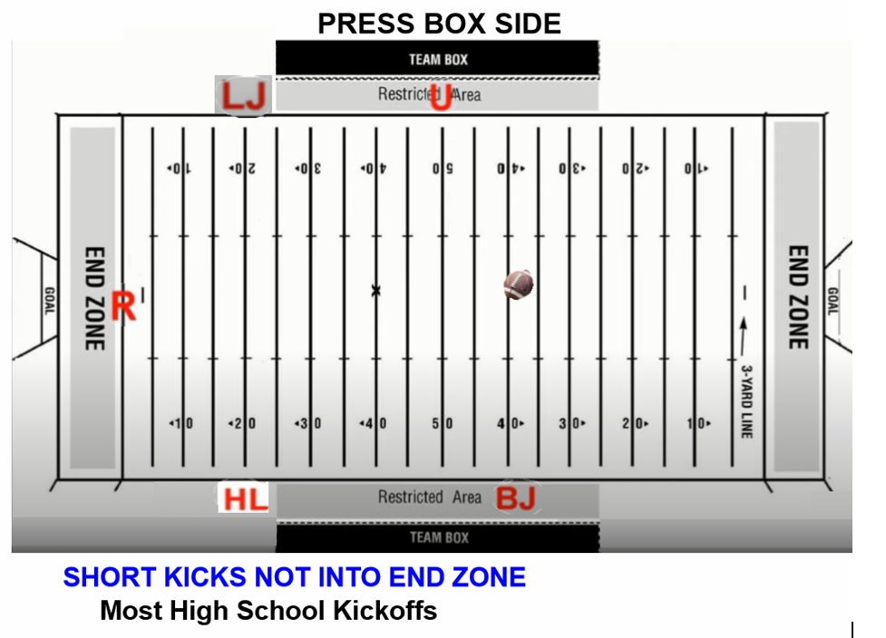

SHORT KICK (Most High School Kickoffs)
40 (kicking restraining line) yard line - BJ opposite the press box
50 (receiving restraining line) yard line - U press box side
20 yard line - HL opposite press box
20 yard line - LJ press box side
Goal line - R

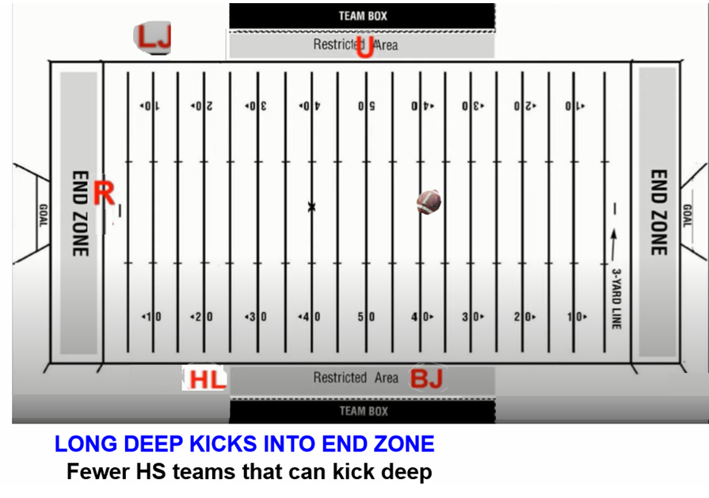

LONG KICK INTO END ZONE (Some High School Kickoffs)
40 (kicking restraining line) yard line - BJ opposite the press box
50 (receiving restraining line) yard line - U press box side
20 yard line - HL opposite the press box
10 yard line - LJ sets up initial position deeper on the press box side
Goal line pylon - R opposite press box

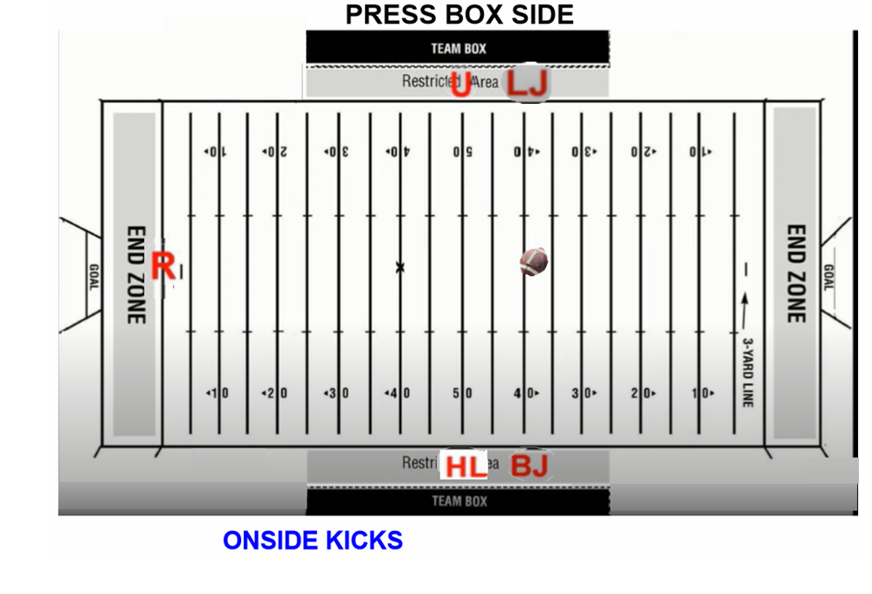
ONSIDE KICK
40 (kicking restraining line) yard line - BJ opposite the press box
50 (receiving restraining line) yard line - U press box side
50 yard line - HL opposite press box
40 yard line - LJ press box side
Goal line - R

b. The BJ checks to see that all kicking team players, except the kicker, are inside of 5 yards.

c. On all free kicks, the R checks to see that kicking team has at least four players on both sides of the kicker when that ball is kicked. The R will blow whistle and shut the kick down if there are only three or less on either side of the kicker when the ball is kicked.

d. Watch the kicker before the game and get a feel for how deep the player kicks the ball. If there is a weak kicker, the R will instruct the officials to move up. This is a game time decision. If you have a kicker who can boot the ball, you don't want to run back and have to run forward. It much easier to come up than it is to go down then back up.

e. Officials covering kicking team's restraining line and receiving teams' restraining line will have bean bags in hand to mark first touching within the restraining lines.

- Running Plays
a. The HL and LJ checks to ensure that the offensive team has no more than 4 players in the backfield, rather than “at least five on the LOS.”

b. When the runner or the ball goes out-of-bounds (OOB) a distance beyond the sideline, do not drop your “Bean Bag” to retrieve the ball, or to follow the runner OOB to retrieve the ball. Stop at the spot of the ball or the runner at the OOB spot, give the "Stop the Clock" signal while watching the dead ball OOB area. The retrieval of the ball is not as important as being a “Dead Ball Watcher”. Wing officials will have ball retrieval help coming from the BJ, and runner observation help. EXCEPTION: When the Runner goes deep into, or into the opponents sideline, now drop your Bean Bag to mark the OOB Spot, and move into the OOB area to assist and observe any illegal actions.
c. When there is a fumble, all officials should be ready to drop a bean bag down to mark the spot of the fumble. Drop the bean bag, avoid throwing it. The first official in digs, the second official in kills the clock, the R will give signal.

d. When digging during a fumble at least one official should keep some distance from the pile to watch and officiate the rest of the players.

6. Passing Plays

a. When the U reads pass play, the U will moved to 2 yards depth to have a good point of reference of the extended neutral zone and for possible ineligibles downfield.

b. The HL, BJ, and LJ will use “Man-Zone-Ball” Technique for eligible receivers coverage.

c. Forward/Backward passes - When in doubt the pass is forward.

d. Quick Passes – the HL and LJ have primary responsibility. (The official that ball is going away from has the best look.)

e. Drop back passes/shotgun – the R has primary responsibility for backward pass. The HL and LJ have secondary responsibility for backward pass.

f. The far side wing official will punch backward passes. The ball remains alive and maybe advanced by anyone on any down. Backward passes OOB will be spotted at OOB spot for all downs as well.

g. If the BJ has a foul for OPI/DPI; then the HL, LJ or U will need to help pick up the flag. There is no foul for OPI/DPI if pass has not crossed NZ.

h. It is important to communicate if the ball on a pass has crossed the neutral zone; might have OPI or DPI.

i. Coverage of receivers/Keys – HL, LJ, BJ
- Discussion led by BJ; HL and LJ should be involved.
- The BJ has widest eligible receiver based on strength (usually the TE). If strength is even, strength will be declared on LJ’s side of the field.
- Discuss motion and how it affects keys. Watch motion for possible crack backs blocks.
g. Complete/Incomplete – HL, LJ, BJ, U, R
- Any official can call incomplete pass, if they are 100% certain.
- If ruled as a catch, covering official (HL, LJ, BJ, U) should sell the spot.
- If there is doubt, the pass should be ruled incomplete.
h. The R is primary on any hit on QB (blind side or front side).
- If the ball comes out, the R will rule incomplete or fumble.
- The R should signal and whistle if the pass is incomplete.
- If ruled a fumble, the R should throw a bean bag.
- The HL and LJ should key off R, delay your whistle to get the proper read from the R.
i. OPI/DPI – HL, LJ, BJ primary.
- OPI calling official needs to report foul to R; non-calling official will cover flag
- DPI non-calling official will cover flag; calling official will report to R
- Whether or not the foul is more or less than 15 yd penalty does not matter in NHFS Rules. The penalty for DPI is 15 yd penalty
- Half the distance apply when previous spot is inside the B30.
- The U will communicate to HL and LJ before enforcing all penalties.

7. Scrimmage Kick Plays

a. The R will call the U over the ball until an accurate count is confirmed by the LJ. With the potential of 44 players coming and going, make sure there is an accurate count.

b. On the scrimmage kicks, the LJ should hold the line and the HL should break on a clean snap. The HL has action in front of the run. Once the ball crosses the LOS, the LJ breaks and picks up action in front of the runner.

c. When the ball becomes dead on a scrimmage kick, the covering official should hold the spot with the opponents ball until the offense brings in a new ball and the ball gets spotted by the U. Once the ball is spotted by the U, the other ball can be removed from the field of play.

8. Field Goal Attempts or Trys

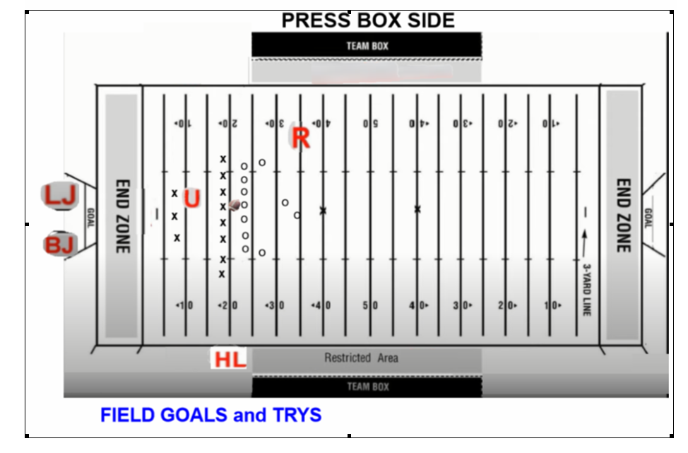

a. The R rules on roughing kicker or holder a 15 yd penalty or running into kicker a 5yd penalty; note positioned on the kicker’s plant leg.

b. The HL will stay on LOS ruling on whether the kick crosses NZ. Officiate all LOS violations.
c. The BJ and LJ are under uprights. The U has roughing the snapper.
d. The BJ has the crossbar and upright opposite the press box. LJ has the upright on the press box side.
e. The BJ will have the whistle.
f. The BJ and LJ should confirm "yes-yes" or "no-no" and then step forward and signal together.
g. The BJ and LJ should hold signal until the R gives the signal to the press box.
h. The HL will put a bean bag down to mark LOS on FG attempts. (In case the chains move; R’s needs to help).
i. The HL will jog in toward the lineman after the ball crosses the LOS. the HL needs to help R control middle of field.
j. Review missed Field Goals. Touchbacks place ball at the 20 yard line.
k. Scrimmage kick rules apply on field goal attempts.
l. All officials need to know ineligible numbers. The U will help on eligible receivers.
m. Remember ineligibles are locked in when the center touches ball.
n. The BJ, LJ, HL, and U should inform crew of the ELIGIBLE numbers they are keying on.
o. If try is blocked or if Team B gains possession the try is over.
Breakdowns on Field Goals and Tries inside the 20
a. The BJ and LJ will officiate their respective side of the field from upright to pylon sliding down the end line.
b. The HL and R will start from the LOS and then move to the Goal line as the play dictates.
c. The HL needs to know if ball crosses the LOS.
Breakdowns on Field Goals and Tries outside the 20
a. The BJ will stay on the end line and officiate from pylon to pylon.
b. The LJ will move up to the Goal line and officiate inside out, helping but not obstructing the view of the HL and R.
c. The HL and R will officiate the sideline to the goal line pylon, moving downfield as play dictates.
d. The HL and U will have responsibilities for roughing the snapper, hurdling and all holding by lineman at LOS.
e. The holder must rise to pass or hand the ball off.
h. The R makes final determination on field goal mechanics and/or positioning.

9. Goal Line Plays

a. The R’s mechanics do not change for Team A going in.

b. The R is responsible for the end line when Team A is coming out.

c. The BJ has the end line when Team A is going in.

d. The HL, LJ , and BJ will change goal line/end line coverage between 12-15 yards. The HL and LJ have the pylon as well as the sideline to end line responsibilities.

e. The HL and LJ need to get to the pylon immediately after the snap when snapping from the 7 yd and in when Team A is going in, and the 5 yd line when A is coming out. Make sure you are two yard off the side line facing the goal line (Be at least two large steps back OOB from the pylon).

f. The HL and LJ must be aware if the line to gain is between the 7 and the goal line. Read the play, if the goal line is not threatened get an accurate spot.

g. The U needs to be positioned in the end zone when snapping from 7 and in. (Do not obstruct HL or LJ view of the goal line) See the ball!

10. Administering Penalties

a. The R confers with the Head Coach on accepting or declining penalties.
b. After the penalty is enforced, the BJ confirms with the R about the status of the clock. Determine if the clock start on the Wind or on the Snap.
c. Know who is responsible for covering the flag and who is responsible for covering the end of the run. This will allow the calling official to report the penalty to the R. The U will march the penalty off with the HL or LJ.

11. Measurements

a. The BJ steadies the ball with their rear end pointing away from the line-to-gain as to allow the measurement to be visible for everyone.

b. Often times the referee needs to discover from the HL, LJ and/or BJ if the clock will on the snap or the ready. The NFHS recommended crew communication signal to start the clock on a the snap is "arms crossed at the wrists in front of the waist" (i.e. after an awarded first down on a play that end out of bounds). However, the Committee recommends a more visible signal be made by the HL, LJ and/or the BJ when communicating starting the clock on the snap to the referee. The more visible signal would be for the signaling official the raise arm at eye level while snapping his fingers. This signal will indicate the clock will start on the snap.

c. Likewise, if the HL, LJ and/or BJ need to communicate to the referee that the clock will start on the ready, the signaling official will simply raise the hand slightly and twirl or rotate in a circle one finger in a "start the clock" fashion.

d. The Committee also recommends the following two communication signals be made to award a first down on a play the ends inbounds near a sideline. Officials will first give the "wind the clock signal" to indicate play ended inbounds, immediately followed by the "kill the clock signal" to award the first down and allow the chains to be moved.

12. Time Out Procedures

[ X ] - Committee Agrees with this section of the NFHS Manual

13. Injury Time Outs

[ X ] - Committee Agrees with this section of the NFHS Manual

14. End of the Period Procedures

[ X ] - Committee Agrees with this section of the NFHS Manual

15. Between Periods Procedures

[ X ] - Committee Agrees with this section of the NFHS Manual

16. Between Halves Procedures

[ X ] - Committee Agrees with this section of the NFHS Manual

