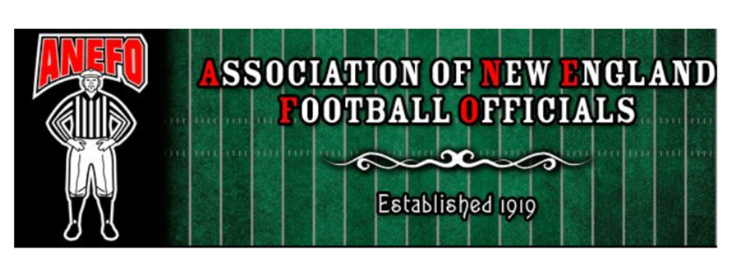

PRESS RELEASE

FOOTBALL OFFICIALS CERTIFICATION COURSE

The Association of New England Football Officials (ANEFO) will be conducting its annual certification course for those persons interested in officiating high school, prep school & youth football. Registration for classes will begin on Monday, August 26, 2024 @ 7:00 PM, Monday Night classes will continue for the next 2 months. Each class will run about 1.25 - 1.50 hours. You must attend a minimum of five classes to take the exam. At conclusion of the course, an exam will be given which, if passed, will certify that person to officiate high school, prep school, & youth football in the state of Massachusetts.

CANDIDATE CLASSES
Monday August 26 - Registration
Monday September 9
Monday September 16
Monday September 23
Monday September 30
Monday October 7
Monday October 21
Sunday October 27 - Review
Monday October 28 - Exam

All candidates who pass the exam will need to attend the on-field clinic the following year.

Cost of the course is $100.00 - Payable to "ANEFO" due by 9/9/2024

All classes will be held at:

Irish-American Club
177 West St.
Malden, MA 02148

Interested parties should attend scheduled registration. (Monday, August 26, 2024 @ 7:00 PM) Any questions, please contact our First Vice President, Steve Ultrino at: ultrinos@msn.com or call Steve at
617-733-7552

