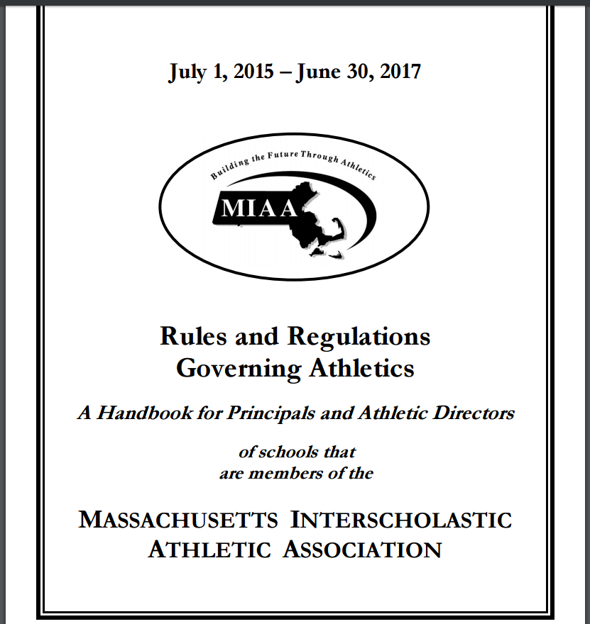

69. Football - MIAA
69.1 Massachusetts high school football shall be played under the NCAA Rules, with the following modifications:
69.1.1 Goal Post uprights shall be a maximum of 23 feet, 4 inches inside to inside. (NCAA Rules: Section 1-2-5-b) MIAA Handbook July 1, 2015 – June 30, 2017
69.1.2 Teams may play with leather or composite leather footballs meeting NFHS specifications. (NCAA Rules: Section 1-3-1-b)
69.1.3 Football helmets of the same color are not required. (NCAA Rules: Section 1-4-4-a-2)
69.1.4 It is not required that football jerseys be long enough to reach the top of the pants and be tucked in. (NCAA Rules: Section 1-4-4-c-1)
69.1.5 Teams are not required to have socks that are identical and the same length. (NCAA Rules: Section 1-4-4-h)
69.1.6 Soft knee pads at least ½ inch thick must cover the knees and be covered by pants. No pads or protective equipment may be worn outside the pants. Players of a team shall wear pants of the same color and design. (NCAA Rule 1-4-4-d)
69.1.7 Use of kicking tee will be permitted for extra point and field goal attempts. (NCAA Rules: Section 2-16-4-a)
69.1.8 A tee may elevate the ball no more than two inches above the ground. (NCAA Rules: Section 2-16-4-c)
69.1.9 The play clock will always be 25 seconds. The 25-second clock is any device under the direction of the appropriate official used to time the 25 seconds between the ready-for-play signal and the ball being put in play. The type of device is determined by the game management. Fields are not required to be equipped with visual 25 second clocks. (NCAA Rules: Section 2-29-2)
69.1.10 On Clocks that display tenths of a second: From 2.1 seconds to 2.9 seconds is considered to be the same as 3 seconds on clocks that do not display tenths. (NCAA Rules 3-2-5)
69.1.11 Clock stops when a ball carrier, fumble or backward pass is ruled out of bounds. The game clock will next start on the snap, except for a forward fumble out of bounds by team A. (NCAA Rules: Section 3-3-2-d-2)
69.1.12 Each team is entitled to five time-outs per half, three of which are a full 90 seconds and two of which will be 30 seconds. Teams may not go to the sideline during a 30 second time-out. (NCAA Rules: Section 3-3-4-a)
69.1.13 There shall be no 10-second runoff in MIAA games as a part of administrating penalties, injuries or helmets coming off. (NCAA Rules 3-3-5-f, 3-3-9-b-2, 3-4-4) MIAA Handbook July 1, 2015 – June 30, 2017 70
69.1.14 The 40 yard line shall be the initial kick-off point. (NCAA Rules: Section 6-1-1) 69.1.15 Touchbacks after free kicks/kickoffs will be placed on the 20 yard line. (NCAA Rules 6-1-7, 8-6-2 Exception)
69.1.16 Any player disqualified from a contest because of Targeting/Initiating Contact With the Crown of the Helmet or Defenseless Player: Contact to Head or Neck Area shall not participate in the next scheduled contest per MIAA Handbook Rule 49.3. (NCAA Rules 9-1-3, 9-1-4)
69.1.17 Conferences/Leagues are not mandated to review flagrant personal fouls. (NCAA Rule 9-6)
69.1.18 There will be no instant replay in MIAA contests. (NCAA Rule 12)
69.2 A licensed physician, licensed trainer or certified EMT must be in attendance and on duty for all interscholastic football games. The medical person shall be responsible for both teams unless the visiting team has its own medical coverage. His/her judgment will be final with regard to the condition of a player after injury. No player may continue to play against the medical person's advice. The penalty for violation of this provision is forfeiture of the game.
69.2.1 The school designated as the home team, or the host site identified with a participating school, must have an AED on site (and accessible) or with their medical person.
69.3 Tie-Breaker Options (Kindly Note: during the regular season leagues and schools also may opt to play no overtime).
69.3.1 To eliminate confusion and misunderstanding, coaches must give a written notice to the referee prior to the kick-off stating whether or not a tie-breaker will be used if the game ends in a tie. It also is important that the news media and the public address announcer be notified before kick-off if a tie-breaker rule is to be used.
69.3.2 The NCAA Football Tie-Breaker Rule, Multiple overtime periods. As modified by the MIAA, conferences or schools may optionally adopt this tie-breaker rule for high school varsity teams. This option will ensure that the game will not end in a tie.
69.3.2.1 During MIAA tournament play additional overtime periods will be used if teams are tied at the end of regulation or succeeding overtime periods. MIAA Handbook July 1, 2015 – June 30, 2017 71
69.3.2.2 Each series shall begin at the ten-yard line unless a penalty overrides. First down chains will not be used. It is always goal-to-go. If penalty enforcement calls for an automatic first down, it will be first and goal.
69.3.2.3 For the first and subsequent tie breaking periods, any team that scores a touchdown must attempt a two point conversion by run or pass from scrimmage.
69.3.2.4 If there is a change of team possession during the last play of an overtime period (second series), live ball personal fouls or live ball unsportsmanlike conduct fouls by opponents of the team last gaining possession, that occur after the change of possession, gives the team in possession the option of putting the ball in play, where the penalty leaves the ball, for one down free of penalty or penalize as a dead ball foul at the succeeding spot in the subsequent overtime period. This option is exercised only if the team last gaining possession is free of foul during the down. Example: Second Series - Team B intercepts Team A's pass and, during Team B's run back, Team A commits a personal foul. Ruling: Team B has the option of extending the overtime period for one down free of penalty, with Team B putting the ball in play where the penalty leaves the ball, provided Team B has not fouled during the down. Or Team B may choose to penalize as a dead ball foul at the succeeding spot in the subsequent overtime period. (NCAA Rules: Section 3-1-3- d, 3-1-3-e, 3-1-3-f 3-1-3-g-1)
69.4 Scheduling Limitations:
69.4.1 The regular season shall end on Thanksgiving Day. When it is necessary to postpone the final scheduled game because of inclement weather, it must be played the weekend following Thanksgiving.
69.4.2 An intra-squad or interschool scrimmage is not to be allowed before the third day of "Full Contact" practice.
69.4.3 The maximum length of periods shall be 12 minutes except when a game ends in a tie, in which case the tie-breaker rule may be used only for varsity games, and if adopted by a majority vote of all schools in the league or by mutual consent in advance of non-league games. Revised 12/30/15 MIAA Handbook July 1, 2015 – June 30, 2017 72
69.5 Participation Limitations:
69.5.1 The first five days of football practice must be single conditioning and "limited contact" sessions. Daily activities shall be limited to the definitions, equipment, time maximums and limitations described in the MIAA Handbook Preseason Practice Chart and Definitions. Violations of these rules will result in a letter of censure by the Board of Directors to the Superintendent of Schools and to the Chairman of the School Committee.
69.5.2 High school football practices prior to the first day of classes must meet the following criteria:
69.5.2.1 During preseason practice, athletes may only participate in full contact – live action drills and game time simulations no more than 60 minutes per athlete per day.
69.5.2.2 From the Monday before Labor Day (August 29, 2016) through the Saturday before Labor Day (September 3, 2016) a coach may only conduct person-to-person full contact drills up to 90 minutes. (The intent of this rule is to limit full contact participation of each student to 90 minutes during this six-day period).
69.5.2.3 From Labor Day through the end of the season, including postseason play, a coach may only conduct full contact drills up to 60 minutes per week (90 minutes during a week without a scheduled game). The intent of this rule is to limit full contact participation of each student to 60 minutes during a week of practice (90 minutes during a week without a scheduled game). During this time, full contact is allowed in no more than 2-3 practices per week, no more than 30 minutes per day, and consideration should also be given to limiting full contact on consecutive days.
69.5.2.4 One day off every week (Definition of a week – MIAA Handbook Rule 34.4: Saturday through Friday, Exception: Thanksgiving and Friday evening games).
69.5.3 A player must participate in at least 15 football practice days before taking part in a football game.
69.5.4 Players may not participate in more than equal time (48 minutes) of one game per week. A week will be from Saturday through Friday except for the week of Thanksgiving Day. (The intent of this rule is to limit participation of each student to no more than one game in any six-day period.). Revised 5/9/16

