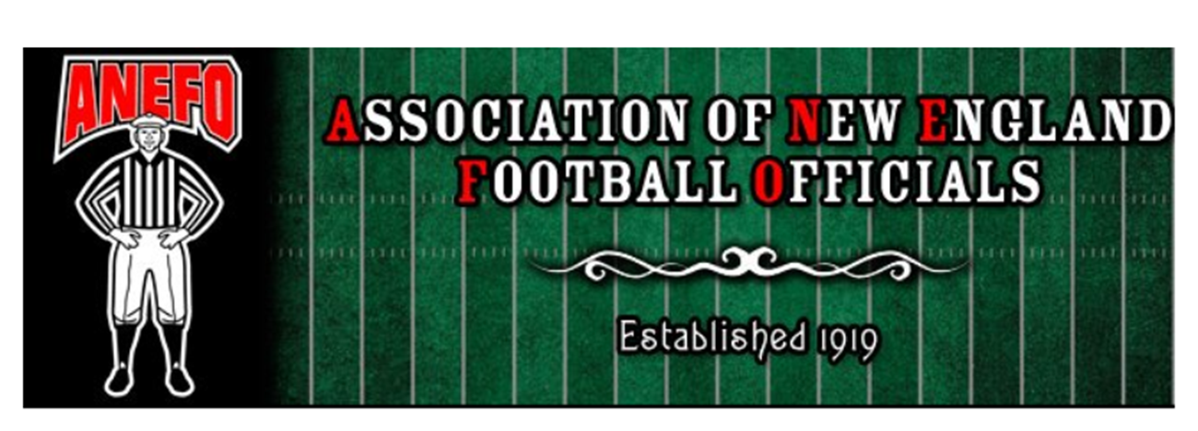

PRESS RELEASE

FOOTBALL OFFICIALS CERTIFICATION COURSE

The Association of New England Football Officials (ANEFO) will be conducting its annual certification course for those persons interested in officiating high school, prep school & youth football. Registration for classes will begin on Monday, August 27, 2018 @ 7:00 PM and weekly classes will continue for 2 months. At conclusion of the course, an exam will be given which, if passed, will certify that person to officiate high school, prep school, & youth football in the state of Massachusetts.

Cost of the course is $100.00.

All classes will be held at:

Irish-American Club
177 West St.
Malden, MA 02148

Interested parties should attend scheduled registration. (Monday, August 27, 2018 @ 7:00 PM) Any questions, please contact our First Vice President, Brian Doherty at
brian.e.doherty@hotmail.com or 781-838-1076.
*Anyone who fails the exam will be able to retake the course and exam the following year for no charge.*

Tentative schedule:
Monday August 27th - Registration, Class overview, and Kicking Game
Tuesday September 4th – Scrimmage Requirements and the Running Game
Monday September 10th – The Passing Game
Monday September 17th – Major Fouls
Monday September 24th – Penalty Enforcement
Monday October 1st – Scoring
Monday October 15th – The Clock and Extra Periods
Monday October 22nd – Rules Review
Wednesday October 24th – Exam

